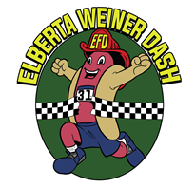
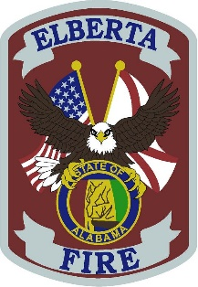
Elberta Volunteer Fire Department Sponsorship 2018
The Elberta Volunteer Fire Department will be hosting the October German Sausage on Saturday, October 27, 2018.
The EVFD invites you to become a sponsor of our 40th October German Sausage Festival and 3rd Annual Weiner Dash 5K and 1 Mile Fun Run/Walk. All proceeds benefit the Elberta Volunteer Fire Department to offset the costs associated with equipment, apparatus and continuous training.
Please see the sponsorship levels below and the registration form included. Thank you for your support!
Gold Sponsor - $1000
- Company Name/Logo on Event T-shirt
- Opportunity to Include Item in Runner Goody Bag
- Company Name Announced Throughout Festival
- Company Name/Logo on Event Sponsor Banners
- Company Name/Logo on EVFD Website and Facebook Recognition
- Opportunity to Provide Company Banner to be Hung at Festival
- 6 Weiner Dash 5K Entries
- Company Logo on Event Billboards (6 Locations)
Silver Sponsor - $500
- Company Name/Logo on Event T-shirt
- Opportunity to Include Item in Runner Goody Bag
- Company Name Announced Throughout Festival
- Company Name/Logo on Event Sponsor Banners
- Company Name/Logo on EVFD Website and Facebook Recognition
- Opportunity to Provide Company Banner to be Hung at Festival
- 4 Weiner Dash 5K Entries
Bronze Sponsor - $200
- Company Name/Logo on Event T-shirt
- Opportunity to Include Item in Runner Goody Bag
- Company Name Announced Throughout Festival
- Company Name/Logo on Event Sponsor Banners
- Company Name/Logo on EVFD Website and Facebook Recognition
- 2 Weiner Dash 5K Entries
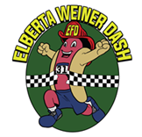
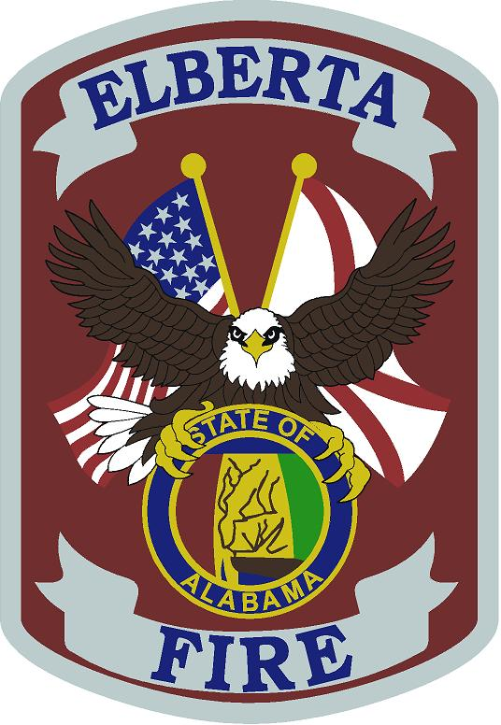
SELECT SPONSORSHIP LEVEL:

Gold Sponsor: _____
Silver Sponsor: ______
Bronze Sponsor: _____

COMPANY NAME________________________________________
CONTACT NAME ________________________________________
MAILING ADDRESS ______________________________________
______________________________________________________
EMAIL ________________________________________________
PHONE _______________________________________________

GOLD SPONSORS – PLEASE SUBMIT YOUR SPONSORSHIP BY SEPTEMBER 1, 2018.
ALL OTHER SPONSORS BY OCTOBER 1, 2018

IF YOU HAVE ANY QUESTIONS OR TO RESERVE YOUR SPONSORSHIP,
PLEASE CONTACT THE ELBERTA VOLUNTEER FIRE DEPARTMENT AT
SPONSORSHIPS@ELBERTAFIRE.COM

PLEASE MAIL COMPLETED FORM AND PAYMENT TO:
ATTN: WOMEN’S AUXILLARY
ELBERTA VOLUNTEER FIRE DEPARTMENT
P.O. BOX 152
ELBERTA, AL 36530

